**Article 33. Standards for Streets, Off-Street Public Paths, & Cross-Access**

**33.1 TECHNICAL STANDARDS**

**33.2 CHARLOTTE STREETS MAP**

**33.3 STREET DESIGN**

**33.4 UPTOWN STREETSCAPE DESIGN**

**33.5 OFF-STREET PUBLIC PATHS**

**33.6 CROSS-ACCESS**

**33.1 TECHNICAL STANDARDS**

Construction and technical details for streets, including in-street drainage and water and sewer utilities, off-street public paths, and cross-access are available in one or more of the following:

**A.** Charlotte Land Development Standards Manual (CLDSM)

**B.** Charlotte-Mecklenburg Storm Water Services Design Manual

**C.** Charlotte Water, Water and Sewer Design and Construction Standards

**D.** CATS Bus Stops – Special Details

**E.** Other city code, state, or federal regulations

**33.2 CHARLOTTE STREETS MAP**

The Charlotte Streets Map (Streets Map) shows the location of existing and planned future arterial and collector streets, and any shared-use paths located along local streets. Collector streets not indicated on the Streets Map shall be located per the standards of Section 32.5.E.

**33.3 STREET DESIGN**

**A.** Table 33-1: Street Design provides a reference for the required location, dimensions, and standards for each street classification.

| **Table 33-1: Street Design** | | | | | | | |
| --- | --- | --- | --- | --- | --- | --- | --- |
|  | **Street Classification** | | | | | | |
| **Limited Access** | **Arterials** | | | **Collector** | **Local** | **Uptown Streets** |
| **Parkway** | **Avenue/Blvd** | **Main Street** |
| **New Street – Location and Classification** | Streets Map | Streets Map | Streets Map | Streets Map or  Sec. 32.5.D | Streets Map or Sec. 32.5.E | If not shown on Streets Map as Limited Access, Arterial, or Collector, or if not established as new Main Street or Collector, then classified as Local;  Table 33-2 determines the required local street type | Streets Map |
| **Existing Street – Classification** | Streets Map | Streets Map | Streets Map | Streets Map | Streets Map | Streets Map |
| **Future Back of Curb Location** | N/A | N/A | Streets Map | Streets Map | CLDSM | CLDSM | Streets Map |
| **Curb and Gutter** | N/A | N/A | Standard curb and gutter per CLDSM | Standard curb and gutter per CLDSM | Standard curb and gutter per CLDSM;  In the N1-A, N1-B, or N1-C Zoning Districts, may be standard or valley gutter | Standard curb and gutter per CLDSM;  In the Neighborhood 1 Zoning Districts, may be standard or valley gutter | See Table 33-6 |
| **Right-of-Way Width Measurement** | Streets Map | Streets Map | Streets Map1 | Streets Map1 | CLDSM1 | CLDSM1, 2 | Measured to the setback location per Streets Map classification and Table 33-6 |

1 The minimum right-of-way is measured to the back of the required sidewalk/shared-use path. If building is two feet or more behind the required shared-use path, the right-of-way shall be increased by two feet or shall be put in a sidewalk utility easement (SUE).

2 Or as reflected on a recorded public access easement for private local streets.

**B.** Table 33-2: Local Street Matrix describes the type of local street required within each Place Type.

|  |  |  |  |  |  |  |  |  |  |  |
| --- | --- | --- | --- | --- | --- | --- | --- | --- | --- | --- |
| **Table 33-2: Local Street Matrix** | | | | | | | | | | |
| **Local Street Types** | **Place Type** | | | | | | | | | |
| **Neighborhood 1** | **Neighborhood 2** | **Neighborhood Center** | **Community**  **Activity Center** | **Regional Activity Center** | **Commercial** | **Campus** | **Innovation Mixed-Use** | **Manufacturing and Logistics** | **Parks and Preserves** |
| **Residential Medium** | Allowed for N1-A, N1-B, N1-C, and N1-D Zoning Districts | Allowed for Condition 1 |  |  |  |  |  |  |  |  |
| **Residential Wide** | Required unless zoned N1-A, N1-B, N1-C, or N1-D Zoning District | Required unless Condition 1 | Allowed for Condition 3 | Allowed for Condition 3 | Allowed for Condition 3 |  |  | Allowed for Condition 3 |  |  |
| **Office/ Commercial Narrow** |  |  |  |  |  | Allowed for Condition 2 | Allowed for Condition 2 for OFC or OG Zoning District |  |  | Allowed for Condition 2 |
| **Office/ Commercial Wide** |  |  | Required unless Condition 3 | Required unless Condition 3 | Required unless Condition 3 | Required unless Condition 2 | Required unless Condition 2 and zoned OFC or OG Zoning District | Required unless Condition 3 |  | Required unless Condition 2 |
| **Industrial** |  |  |  |  |  |  |  |  | Required |  |
| **CONDITIONS**  **Condition 1 –** The developer can reasonably demonstrate to the Planning Department, in consultation with the Charlotte Department of Transportation (CDOT), that alternative provisions can be made to ensure adequate on-site parking.  **Condition 2 –** The developer can reasonably demonstrate to the Planning Department, in consultation with CDOT, that the anticipated long-term development will not create parking demand on the street.  **Condition 3 –** Allowed for a residential development that abuts N1 or N2 zoning districts along an existing local street, if the developer can reasonably demonstrate to the Planning Department, in consultation with CDOT, that the change will not affect the function of the street or the adjacent street network for parking, loading, maneuvering, and/or access.  **NOTE:** While a common design for parking and streetscape on both sides of a local street is preferred, there may be instances where opposite sides of a local street contain different Place Types. In such instances, the Planning Department, in consultation with CDOT, may approve the design of each side of the local street separately regarding the parking and streetscape so long as the resulting corridor operates in a functional and cohesive manner.  New partial streets shall be constructed to the standards of the required local street cross-section per this table, not including streetscape on the incomplete portion of the partial street. | | | | | | | | | | |

**C.** Table 33-3: Streetscape Reference provides a reference for the required sidewalk/shared-use path and amenity zone or planting strip for each street classification.

| **Table 33-3: Streetscape Reference** | | | | | | | |
| --- | --- | --- | --- | --- | --- | --- | --- |
|  | **Street Classification** | | | | | | |
| **Limited Access** | **Arterials** | | | **Collector** | **Local** | **Uptown Streets** |
| **Parkway** | **Avenue/Blvd** | **Main Street** |
| **Sidewalk/ Shared-Use Path Dimension** | N/A; Unless indicated on Streets Map1 | Streets Map1 | Streets Map | Streets Map | See Table 33-4, unless a Shared-Use Path shown on Streets Map | See Table 33-4, unless a Shared-Use Path shown on Streets Map | See Table 33-6 |
| **Required Amenity Zone or Required Planting Strip**2 | Planting Strip3 | Planting Strip3 | Streets Map4 | Streets Map | See Table 33-5 | See Table 33-5 | Amenity Zone |
| **Required Amenity Zone or Required Planting Strip Dimension** | 8 feet 5 | | | | | | See Table 33-6 5 |

1 Any pedestrian facilities on Limited Access roads and Parkways will be in the form of a shared-use path located either in a sidewalk utility easement outside the right-of-way or, with NCDOT approval, at the back of the right-of-way.

2 Where the area between the sidewalk and the back of curb is three feet or more than the required minimum width of an amenity zone, grass or groundcover is permitted in the area that exceeds the required minimum width. If the area between the sidewalk and the back of curb is three feet or less than the required minimum width of an amenity zone, the amenity zone shall extend to the back of curb.

3 Locationof trees may be required to be outside the clear zone for North Carolina Department of Transportation (NCDOT) facilities.

4 If the Charlotte Streets Map requires an amenity zone, a planting strip is permitted instead of an amenity zone for the TOD-TR Zoning District.

5 If the Chief Urban Forester determines that planting trees in the required planting strip or amenity zone is not feasible due to shallow depth of existing underground utilities, the required trees may be relocated behind the sidewalk. In that case, a minimum four foot planting strip, planted with grass or groundcover, shall be retained for collector and local streets. A minimum eight foot planting strip planted with grass or groundcover shall be retained for arterials.

**D.** Table 33-4: Sidewalk Dimensions – Collector and Local Streets contains the required dimensions for sidewalks on collector and local streets based on Place Type. For collector and local streets, a shared-use path shall be required instead of a sidewalk when shown on the Charlotte Streets Map.

| **Table 33-4: Sidewalk Dimensions – Collector and Local Streets** | | |
| --- | --- | --- |
| **Place Type** | **Sidewalk - 6 feet** | **Sidewalk - 8 feet** |
| **Neighborhood 1** | Collector & Local |  |
| **Neighborhood 2** |  | Collector & Local |
| **Neighborhood Center** |  | Collector & Local |
| **Community Activity Center** |  | Collector & Local |
| **Regional Activity Center** |  | Collector & Local |
| **Commercial** | Collector & Local |  |
| **Campus** | Collector & Local, if zoned the OFC, OG, or IC-1 Zoning Districts | Collector & Local for all other zoning districts |
| **Innovation Mixed-Use** |  | Collector & Local |
| **Manufacturing and Logistics** | Collector & Local |  |
| **Parks and Preserves** | Collector & Local, for all zoning districts not listed to the right | Collector & Local, if zoned a Neighborhood Center Zoning District, Community Activity Center Zoning District, Regional Activity Center Zoning District, Innovation Mixed-Use Zoning District, or IC-2 or RC Zoning Districts |

**E.** Table 33-5: Amenity Zone or Planting Strip – Collector and Local Streets indicates when amenity zones or planting strips are required and allowed based on Place Type.

|  |  |  |
| --- | --- | --- |
| **Table 33-5: Amenity Zone or Planting Strip – Collector and Local Streets** | | |
| **Place Type** | **Amenity Zone** | **Planting Strip 3** |
| **Neighborhood 11** | Allowed instead of a planting strip | Required |
| **Neighborhood 2 if zoned N2-A, N2-B1 Zoning Districts** | Allowed instead of a planting strip | Required |
| **Neighborhood 2 if zoned N2-C Zoning District** | Required when abutting on-street parking | Allowed when not abutting on-street parking |
| **Neighborhood Center** | Required when abutting on-street parking | Allowed when not abutting on-street parking |
| **Community Activity Center**2 | Required when abutting on-street parking | Allowed when not abutting on-street parking |
| **Regional Activity Center**2 | Required when abutting on-street parking | Allowed when not abutting on-street parking |
| **Commercial** | Required when abutting on-street parking | Allowed when not abutting on-street parking |
| **Campus if zoned IC-1, OFC, OG1 ZoningDistricts** | Allowed instead of a planting strip | Required |
| **Campus if zoned IC-2 or RC Zoning District** | Required when abutting on-street parking | Allowed when not abutting on-street parking |
| **Innovation Mixed-Use** | Required when abutting on-street parking | Allowed when not abutting on-street parking |
| **Manufacturing and Logistics1** | Allowed instead of a planting strip | Required |
| **Parks and Preserves1** | Allowed instead of a planting strip | Required |

**1**Planting strips are the standard requirement for these Place Types. Amenity zones may be allowed if the Chief Urban Forester, in consultation with the CDOT Director and Planning Director, determines installation of an amenity zone supports the listed urban forest characteristics for the corresponding Place Type while also supporting other key interests (transportation, sidewalks, etc.)

**2**Planting strips are permitted instead of an amenity zone in the TOD-TR Zoning District.

**3** Planting strips are permitted for any zoning district located within the Water Supply Watershed Protection Areas per Article 23.

**33.4 UPTOWN STREETSCAPE DESIGN**

Table 33-6: Uptown Streetscape Design Elements contains the required dimensions for sidewalks and amenity zones and indicates streetscape requirements for amenity zone elements, pavers, lighting, and curb design for Uptown Streets.

| **Table 33-6: Uptown Streetscape Design Elements** | | | | | |
| --- | --- | --- | --- | --- | --- |
|  | **Uptown Street Classifications** | | | | |
| **Uptown Signature Street** | **Linear Park** | **Uptown Primary** | **Uptown Secondary** | **Tryon Street 1** |
| **Sidewalk/ Shared-Use Path Dimension** | 12’ | 12’ | 10’ | 8’ | 12’ |
| **Required Amenity Zone Dimension** | 9.5’ | 9.5’ | 8’ | 8’ | 9.5’ |
| **Amenity Zone Elements** | Tree Grates 2 | Planter no more than 16’ in width | Tree Grates 2 | Tree Grates | Tree Grates 2 |
| **Pavers** | CLDSM 3 | CLDSM 3 | CLDSM 3 | CLDSM 3 | Tryon Street Mall Streetscape Guidelines |
| **Pedestrian Lighting4** | Required-Open Deluxe Acorn with 60’-80’ spacing 4 | Required-Open Deluxe Acorn with 60’-80’ spacing 4 | Required-Open Deluxe Acorn with 60’-80’ spacing 4 | Required-Open Deluxe Acorn with 60’-80’ spacing 4 | Required to match existing |
| **Curb and Gutter** | Granite Curb | Granite Curb | Standard per CLDSM | Standard per CLDSM | Required to match existing |

**1** Tryon Street (within Uptown) shall follow existing Tryon Street Mall Streetscape Guidelines for amenity zone elements, pavers, lighting, and curb design but shall otherwise be classified as an Uptown Signature Street.

**2**Utilities are required in Tree Grates.

**3** Concrete paver blocks in herringbone are permitted under encroachment agreement from applicable agency.

**4** Pedestrian lighting spacing is based on proximity to trees and street lighting, as determined by CDOT. Typically, where trees are spaced 40’ apart, provide lighting at 80’ spacing, alternating between pedestrian lighting and street lighting. Where trees are spaced 30’ apart, provide lighting at 60’ spacing with one street light for every two pedestrian lights.

**33.5 OFF-STREET PUBLIC PATHS**

**A. Transit Trail**

**1.** The minimum width of a transit trail, and any required planting strip or other elements, are based on the applicable Council-adopted transit trail plan.

**2.** No tree planting associated with the construction of a transit trail is required unless indicated by a Council-adopted transit trail plan.

**B. Connections to Off-Street Public Paths or Parks**

The minimum width of a connection to an off-street public path or park is twelve feet. If combined with other required access such as fire, loading, or service access, then the connection shall meet the greater of the required dimensions. The developer shall consult with the staff of the entity having jurisdiction over the facility being connected to in order to determine if any design and/or width modifications are necessary to ensure that any intended purposes can be provided adequately and safely.

**C. Pedestrian and Bicycle Connection**

**1.** For parcels located in the Neighborhood 2 Place Type, Neighborhood Center Place Type, Community Activity Center Place Type, Regional Activity Center Place Type, or Innovation Mixed-Use Place Type, or zoned the IC-2 or RC Zoning District, the minimum width of a pedestrian and bicycle connection shall be twelve feet, with five feet abutting each side of thepath.

**a.** No buildings or structures shall be in the five foot area abutting each side of the path.

**b.** No fixed obstacles to pedestrian or bicycle traffic shall be within two feet of the path’s edge.

**2.** For parcels located in the Neighborhood 1 Place Type, Commercial Place Type, or Manufacturing and Logistics Place Type, or zoned the IC-1, OFC, or OG Zoning District, the minimum width of a pedestrian and bicycle connection shall be eight feet, with four feet abutting each side of thepath.

**a.** No buildings or structures shall be in the four foot area abutting each side of the path.

**b.** No fixed obstacles to pedestrian or bicycle traffic shall be within two feet of the path’s edge.

**CONNECTIONS TO OFF-STREET PUBLIC PATHS OR PARKS**

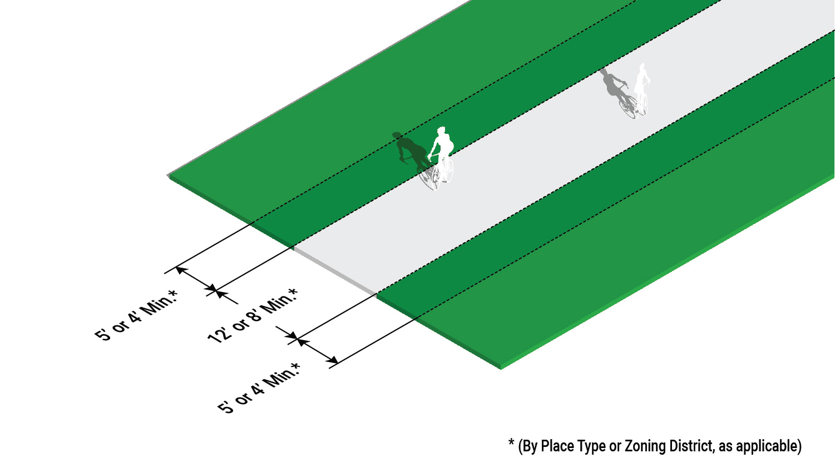**PEDESTRIAN AND BICYCLE CONNECTION**

**33.6 CROSS-ACCESS**

A cross-access connection shall have a minimum 20 foot wide two-way paved connection.